S1. Algorithm of subjects’ collection and exclusion
Time: 2007-2014,
N=5,742
Exclusion: Incomplete data of UA data, N=1536
(all included subjects should have 3 data at least)
CKD Stage 3
N=2,510
N=974

Exclusion: death within 2 years
N=166
N=808

)

Supplementary data, S1
Detailed methods of model building process
Mean of uric acid level within each 6 months was used to establish the trajectories of uric acid. To determine the number of trajectories in our study, different trajectories of mean uric acid (UA) were tested. We started from two and gradually increased to four memberships. This process was performed by the SAS Proc Traj procedure. Information of the Bayesian information criterion (BIC) and percentage of each membership were plotted. Besides, to decide the optimal number of memberships, log Bayes factor need to be calculated. The log Bayes factor was approximately estimated equal to two times the difference in BIC values from the complex and simple models. Log Bayes factor ≈ 2 x [Δ BIC] = 2 x [complex model – simpler model]. The log Bayes factor weighted of evidence surrounding the more complex model which also ensure model parsimony (Jones, Nagin, & Roeder, 2001, www.andrew.cmu.edu/user/bjones/pdf/ref1.pdf, accessed 28 July 2017). The strength in favor of the complex model was weak, moderate, strong and very strong for values of log Bayes factor ranging from 0–2, 2–6, 6–10 and > 10, respectively. Finally, if possible, we expect a minimum percentage of group membership probabilities > 3%. By this process, four memberships of Uric acid trajectories were optimal. However, a group membership probabilities will be less than 3% in 4 memberships. Ultimately, three memberships of mean UA trajectory, rather than four memberships were chosen.

Model-building process for Uric acid trajectories
Assigned group of trajectory | Exact group of trajectory | BIC | Log Bayes factor $≈$ 2 x [Δ BIC] | Minimal % of group membership probabilities | Trajectory plot
2 | 2 | -5869.29 |  | 38 | 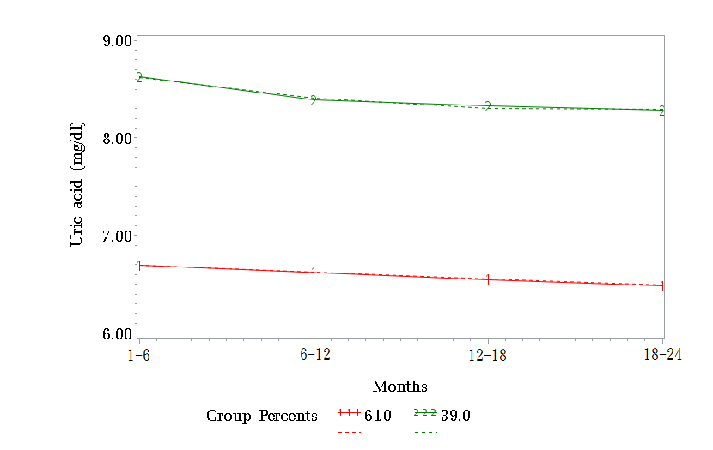
3 | 3 | -5176.37 | 1385.84 | 16 | 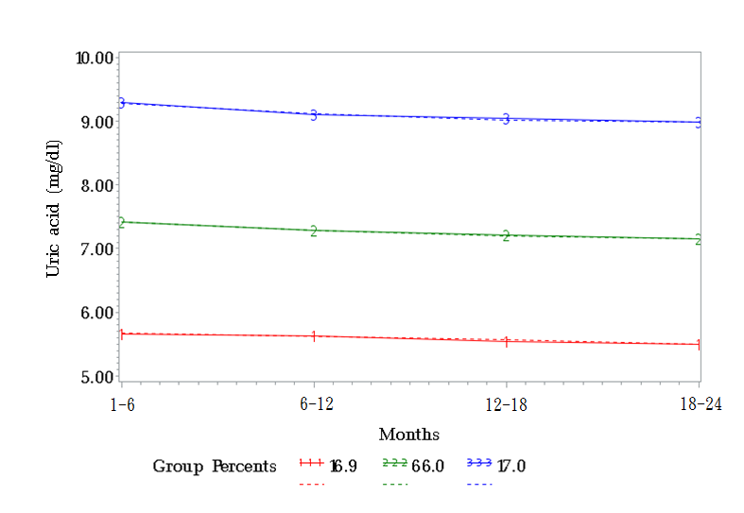
4 | 4 | -5161.27 | 30.2 | 2.3 | 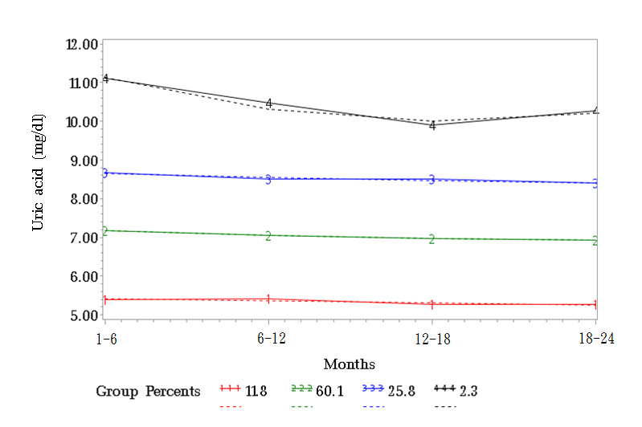
Estimated log Bayes factor defined as: log Bayes factor ≈ 2 x [Δ BIC] = 2 x [complex model – simpler model]

S3 Comparisons of renal and patient outcome between all six trajectories
S3-1 Mortality between all six trajectories
 | Low UA no treatment | Low UA on treatment | Medium UA no treatment | Medium UA on treatment | High UA no treatment | High UA on treatment
Low UA no treatment | n/a | 0.7984 | 0.2759 | 0.2634 | 0.3625 | 0.1608
Low UA on treatment |  | n/a | 0.5789 | 0.5487 | 0.6169 | 0.3522
Medium UA no treatment |  |  | n/a | 0.2206 | 0.3051 | 0.1819
Medium UA on treatment |  |  |  | x n/a | 0.3171 | 0.2237
High UA no treatment |  |  |  |  | n/a | 0.2532
High UA on treatment |  |  |  |  |  | n/a
S3-2 The probability of dialysis between all six trajectories
 | Low UA no treatment | Low UA on treatment | Medium UA no treatment | Medium UA on treatment | High UA no treatment | High UA on treatment
Low UA no treatment | n/a | 0.7984 | 0.2393 | 0.4467 | 0.0782 | 0.7279
Low UA on treatment |  | n/a | 0.5402 | 0.7879 | 0.2935 | n/a
Medium UA no treatment |  |  | n/a | 0.1311 | 0.0911 | 0.4077
Medium UA on treatment |  |  |  | n/a | 0.0301 | 0.7093
High UA no treatment |  |  |  |  | n/a | 0.1787
High UA on treatment |  |  |  |  |  | n/a

S3-3 Mortality or dialysis between all six trajectories
 | Low UA no treatment | Low UA on treatment | Medium UA no treatment | Medium UA on treatment | High UA no treatment | High UA on treatment
Low UA no treatment | n/a | 0.6361 | 0.1236 | 0.2353 | 0.0552 | 0.237
Low UA on treatment |  | n/a | 0.3084 | 0.4298 | 0.1766 | 0.3522
Medium UA no treatment |  |  | n/a | 0.1421 | 0.107 | 0.2897
Medium UA on treatment |  |  |  | n/a | 0.0751 | 0.2746
High UA no treatment |  |  |  |  | n/a | 0.2847
High UA on treatment |  |  |  |  |  | n/a

